Test Case: tc001_SPX_Dev5_Crear_Nueva_Linea_Requisicion_Spot_Tipo_Cobro_CC
Step 1 - Enter username and password and click to button Enter : Credentials Entered
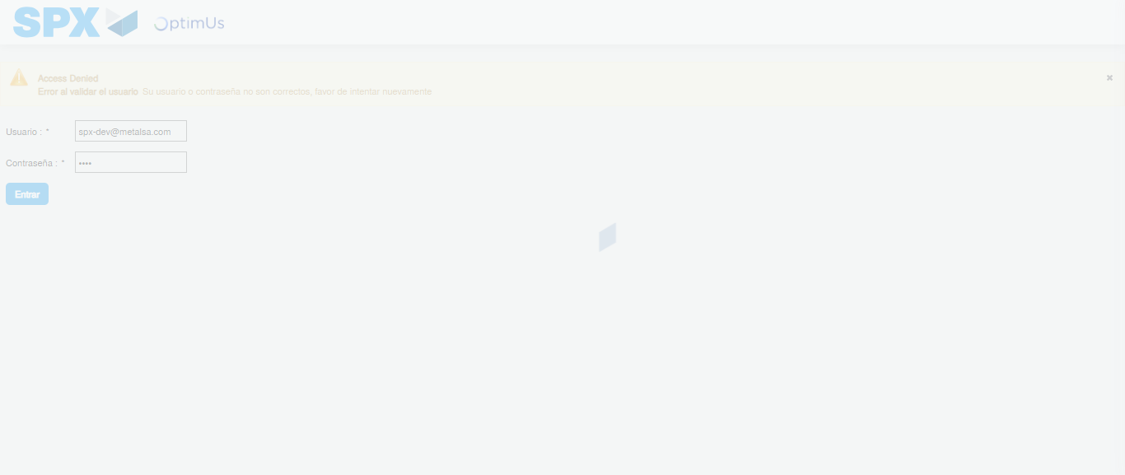Image file-name: QC_Testing-tc001_SPX_Dev5_Crear_Nueva_Linea_Requisicion_Spot_Tipo_Cobro_CC-1790174830266

Step 2 - Select to UEN and Access to Spot Buy Requisitions : UEN Correctly selected and Correct access
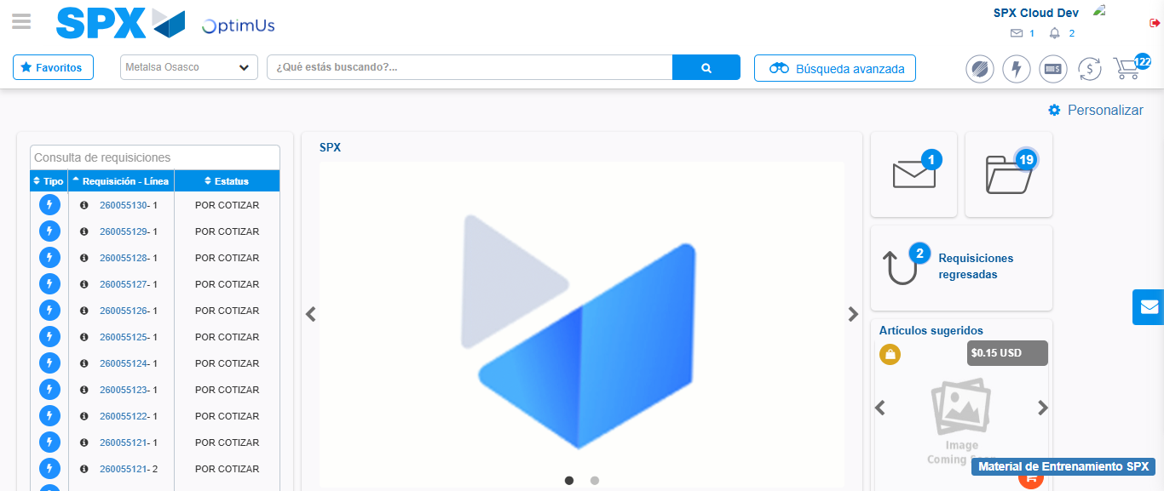Image file-name: QC_Testing-tc001_SPX_Dev5_Crear_Nueva_Linea_Requisicion_Spot_Tipo_Cobro_CC-1790174868367

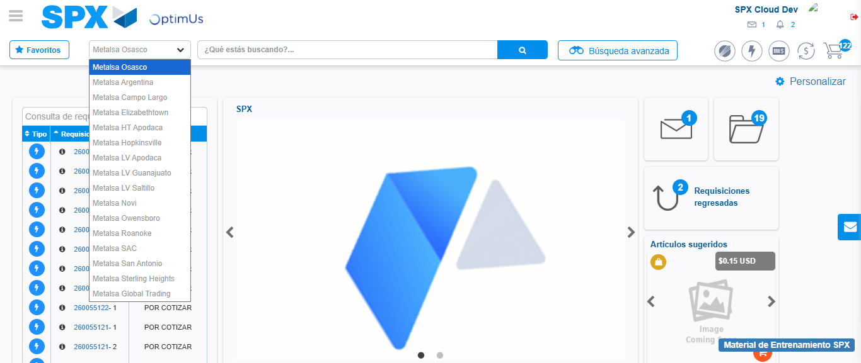Image file-name: QC_Testing-tc001_SPX_Dev5_Crear_Nueva_Linea_Requisicion_Spot_Tipo_Cobro_CC-1790174869143

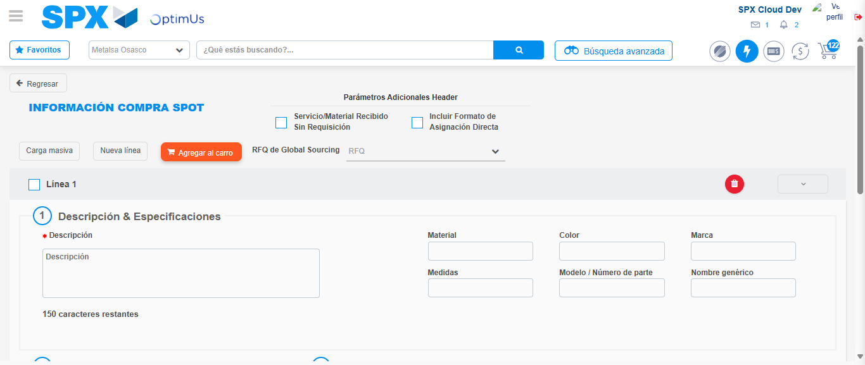Image file-name: QC_Testing-tc001_SPX_Dev5_Crear_Nueva_Linea_Requisicion_Spot_Tipo_Cobro_CC-1790174873679

Step 3 - Data Capture Spot Buy Requisition: Data captured correctly
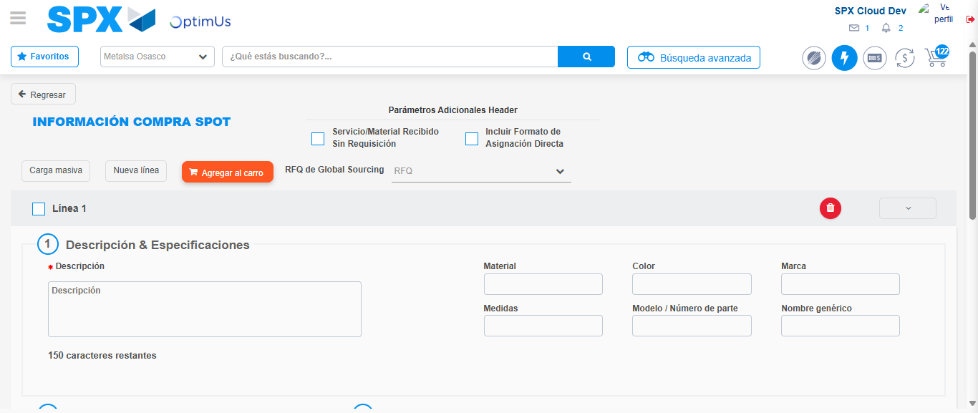Image file-name: QC_Testing-tc001_SPX_Dev5_Crear_Nueva_Linea_Requisicion_Spot_Tipo_Cobro_CC-1790174873973

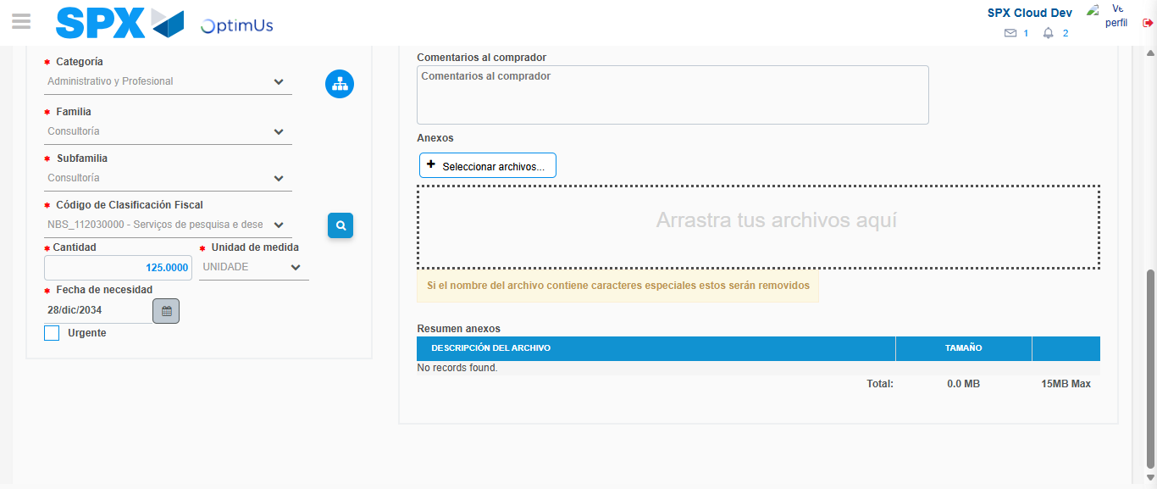Image file-name: QC_Testing-tc001_SPX_Dev5_Crear_Nueva_Linea_Requisicion_Spot_Tipo_Cobro_CC-1790174892656

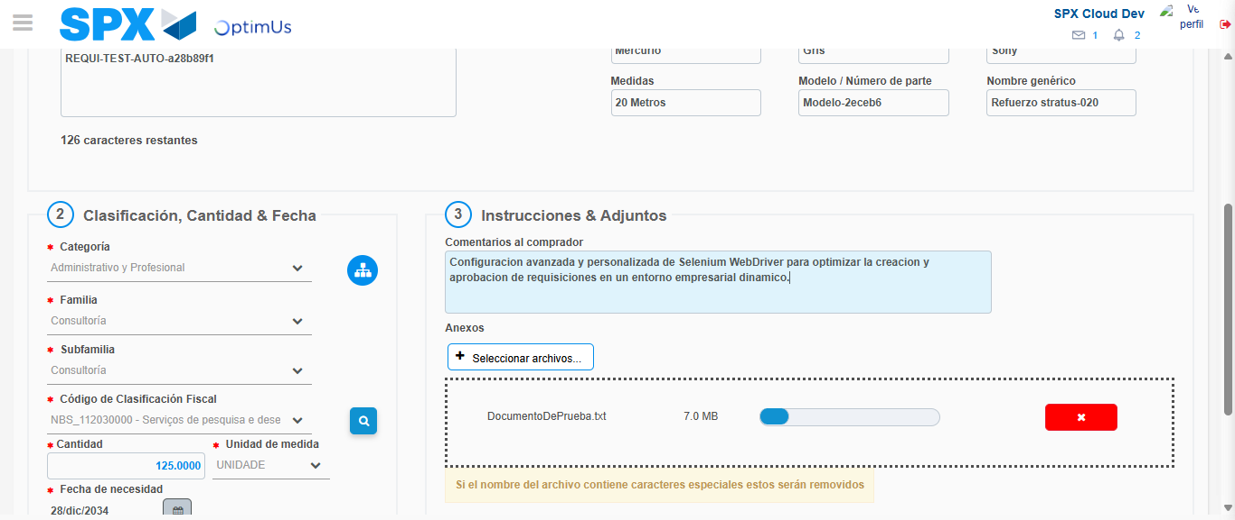Image file-name: QC_Testing-tc001_SPX_Dev5_Crear_Nueva_Linea_Requisicion_Spot_Tipo_Cobro_CC-1790174893675

Step 4 - Add new line and data capture second line: Line add correctly
Image file-name: QC_Testing-tc001_SPX_Dev5_Crear_Nueva_Linea_Requisicion_Spot_Tipo_Cobro_CC-1790174873973

Image file-name: QC_Testing-tc001_SPX_Dev5_Crear_Nueva_Linea_Requisicion_Spot_Tipo_Cobro_CC-1790174892656

Image file-name: QC_Testing-tc001_SPX_Dev5_Crear_Nueva_Linea_Requisicion_Spot_Tipo_Cobro_CC-1790174893675

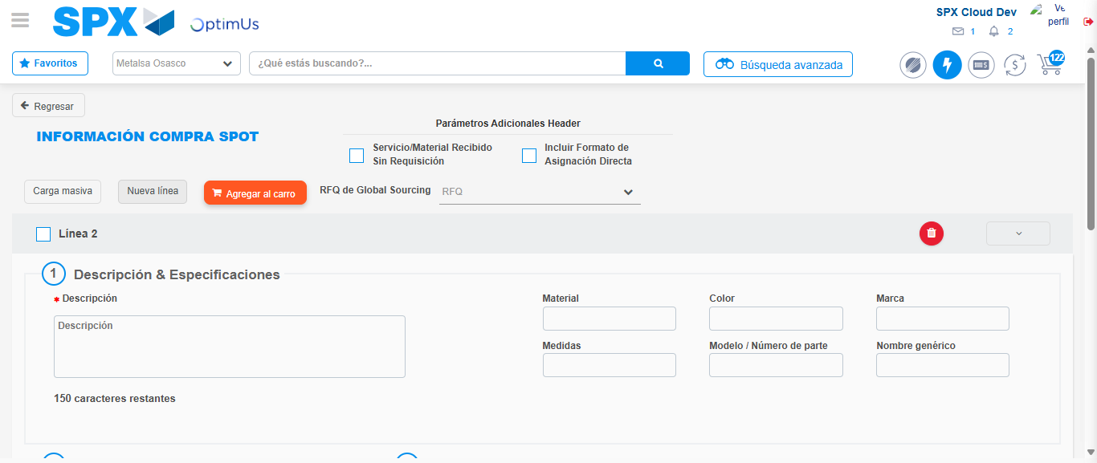Image file-name: QC_Testing-tc001_SPX_Dev5_Crear_Nueva_Linea_Requisicion_Spot_Tipo_Cobro_CC-1790174896069

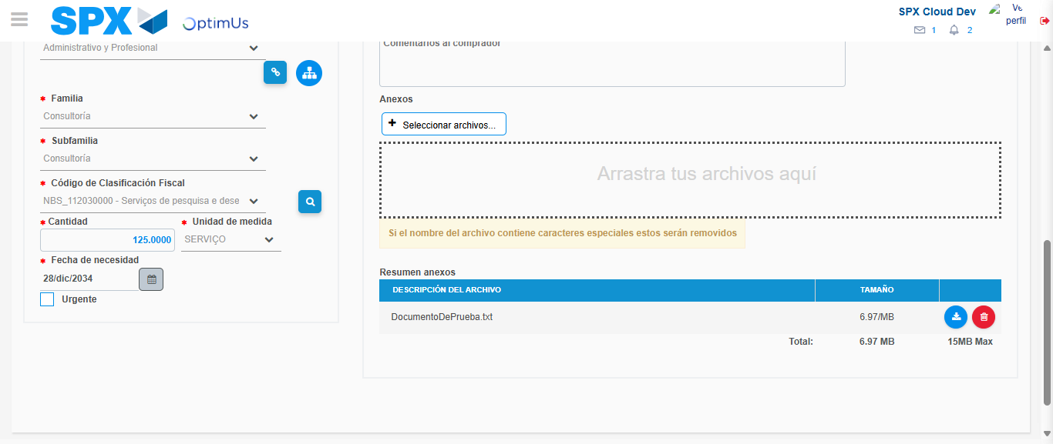Image file-name: QC_Testing-tc001_SPX_Dev5_Crear_Nueva_Linea_Requisicion_Spot_Tipo_Cobro_CC-1790174913670

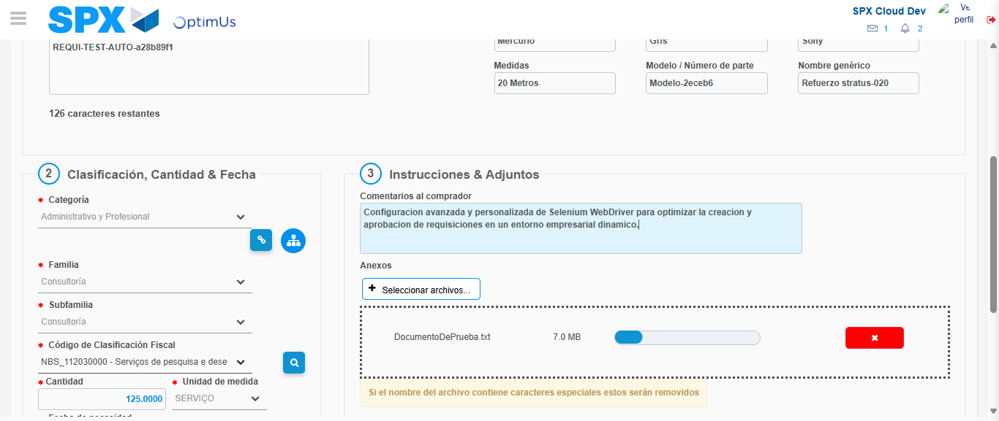Image file-name: QC_Testing-tc001_SPX_Dev5_Crear_Nueva_Linea_Requisicion_Spot_Tipo_Cobro_CC-1790174914736

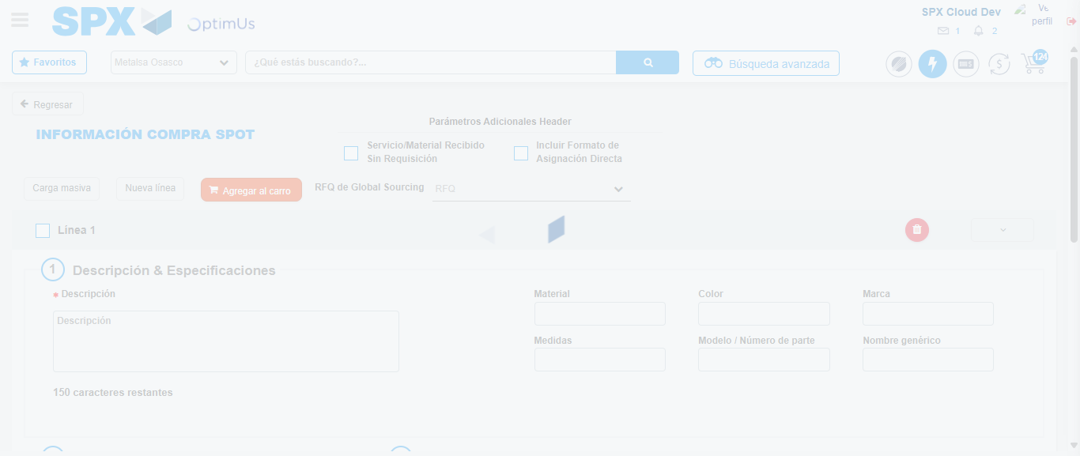Image file-name: QC_Testing-tc001_SPX_Dev5_Crear_Nueva_Linea_Requisicion_Spot_Tipo_Cobro_CC-1790174923935

Step 8 - Return to Main Page SPX : Return to Main Page SPX
Image file-name: QC_Testing-tc001_SPX_Dev5_Crear_Nueva_Linea_Requisicion_Spot_Tipo_Cobro_CC-1790174868367

Image file-name: QC_Testing-tc001_SPX_Dev5_Crear_Nueva_Linea_Requisicion_Spot_Tipo_Cobro_CC-1790174869143

Image file-name: QC_Testing-tc001_SPX_Dev5_Crear_Nueva_Linea_Requisicion_Spot_Tipo_Cobro_CC-1790174873679

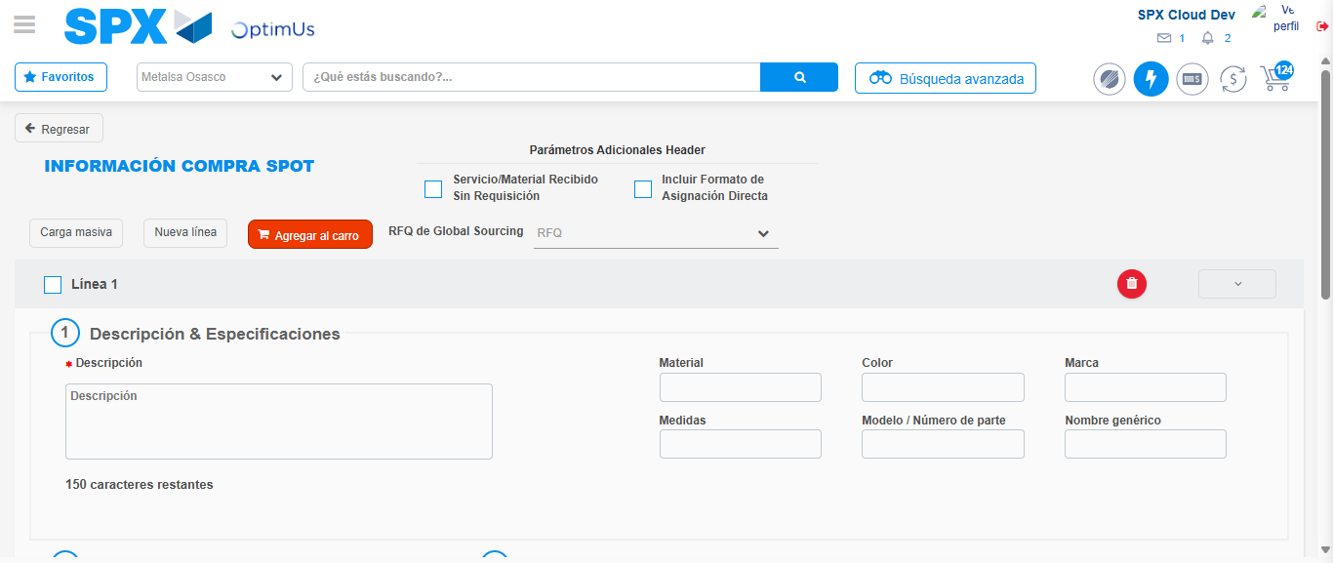Image file-name: QC_Testing-tc001_SPX_Dev5_Crear_Nueva_Linea_Requisicion_Spot_Tipo_Cobro_CC-1790174926225

Image file-name: QC_Testing-tc001_SPX_Dev5_Crear_Nueva_Linea_Requisicion_Spot_Tipo_Cobro_CC-1790174926448

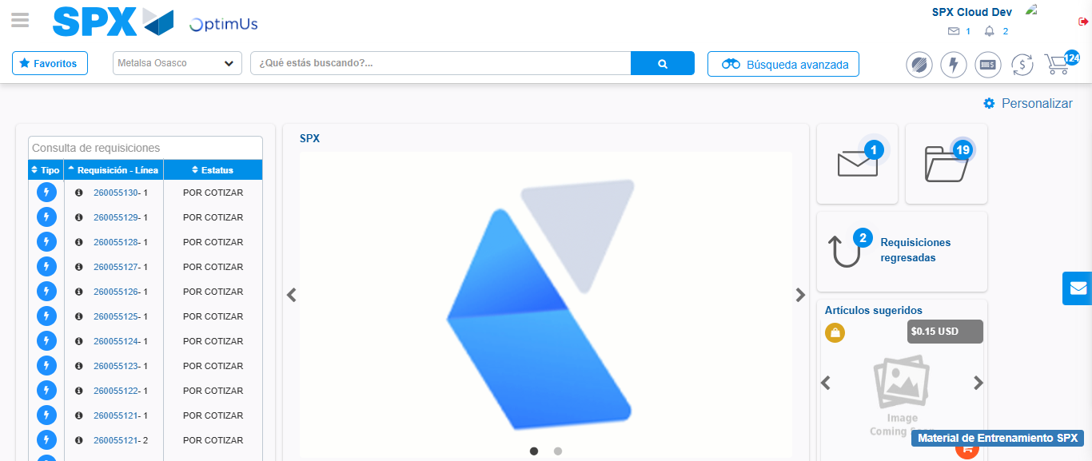Image file-name: QC_Testing-tc001_SPX_Dev5_Crear_Nueva_Linea_Requisicion_Spot_Tipo_Cobro_CC-1790174948010

Step 9 - Log Out : Log Out SPX
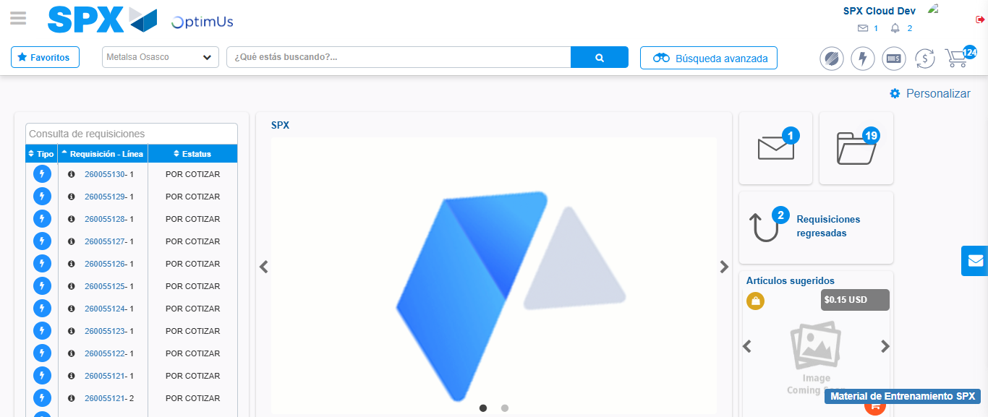Image file-name: QC_Testing-tc001_SPX_Dev5_Crear_Nueva_Linea_Requisicion_Spot_Tipo_Cobro_CC-1790174948371

